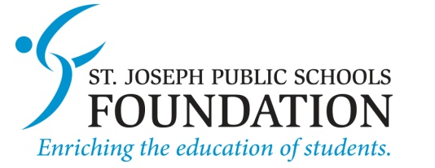
NEw Teacher Welcome grant request

Since 2005, The St. Joseph Public Schools Foundation has provided grants to teachers for activities and programs that are not funded by the general fund of the school district. These are grants specifically for teachers to use in their classrooms. Funds must be used within the academic year for which they are granted. New Teacher Welcome Grants will be awarded during the teacher’s first academic year on staff only.

Application Instructions: Please answer every question clearly and concisely, providing detail when needed. Once you have completed your application, EMAIL the signed document to Foundation Administrative Director, Sue Riemland at sjpsfoundation@sjschools.org.

- Date of Application:
- Name of Applicant and Job Title:

- Schools and grades impacted by this project. Include number of students:

- Applicant Email and Phone #:
- Project Name:

- Requested Amount:
- Describe the project in detail and provide rationale for WHY it is important and HOW it will impact students:

- How will you measure success?

- Project Timeline:

- How will this enhance the curriculum?

- Frequency of Use:

- Budget: Include itemized list of expenses:

Approval Statement

☐ I have discussed this proposal with the principal(s) for the schools impacted by this project.

___________________________________________
Applicant Signature and Date

